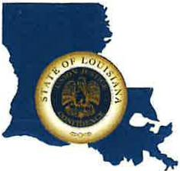 | CAPITAL AREA GROUNDWATER CONSERVATION DISTRICT
GARY I. BEARD
EXECUTIVE DIRECTOR

MEETING NOTICE
Capital Area Groundwater Conservation District
Technical Committee Meeting

WHEN: Tuesday, July 18, 2023

TIME: 1:00 p.m.

WHERE: Capital Area Groundwater office
3074 Westfork Dr., Suite A
Baton Rouge, LA 70816

Contact Person: Lisa Manda, (225)293-7370

